AI Assistant Coding
Assignment 3.1
Name : Aravind
Roll No : 2303A52049
Batch – 32

Question 1:
Zero-Shot Prompting (Palindrome Number Program)
Write a zero-shot prompt (without providing any examples) to generate a java function that checks whether a given number is a palindrome.
Task:
• Record the AI-generated code.
• Test the code with multiple inputs.
• Identify any logical errors or missing edge-case handling.
Prompt:
Code:
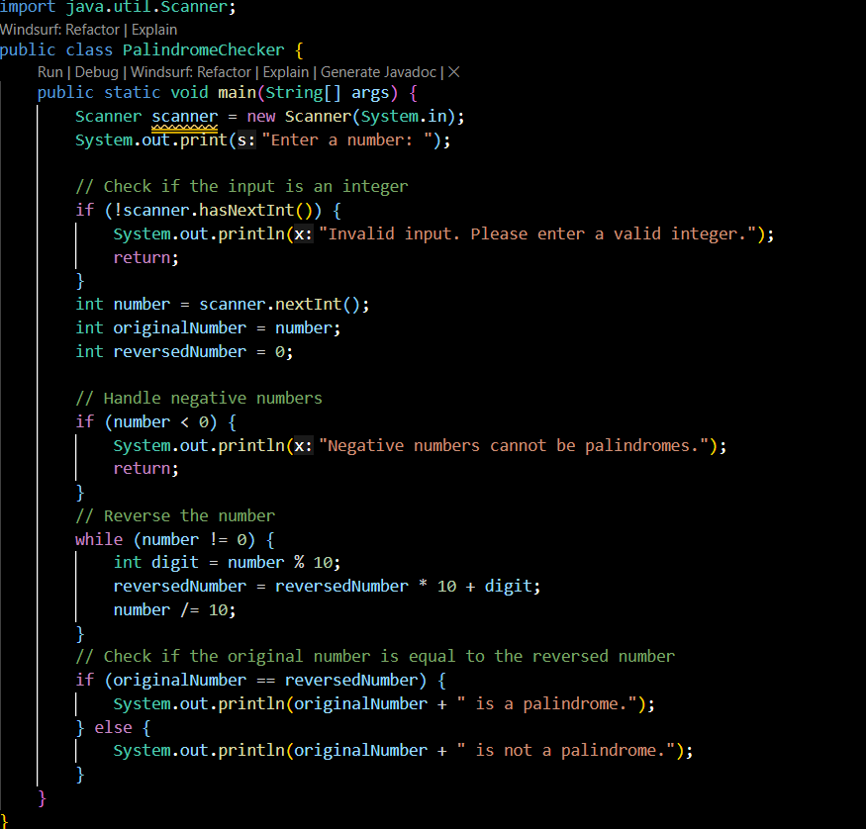
Output:
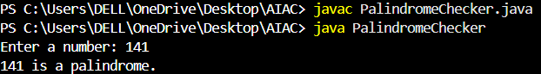
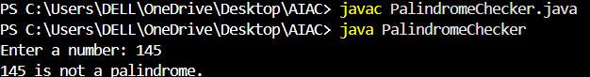
Explanation :
This program checks whether a given number is a palindrome or not.
It takes input from the user, reverses the number using a loop, and then compares the reversed number with the original number.
If both are the same, the number is a palindrome; otherwise, it is not.
Negative numbers are handled separately.
Question 2:
One-Shot Prompting (Factorial Calculation)
Write a one-shot prompt by providing one input-output example and ask the AI to generate a java function to compute the factorial of a
given number.
Example:
Input: 5 → Output: 120
Task:
• Compare the generated code with a zero-shot solution.
• Examine improvements in clarity and correctness.
Prompt:
Code :
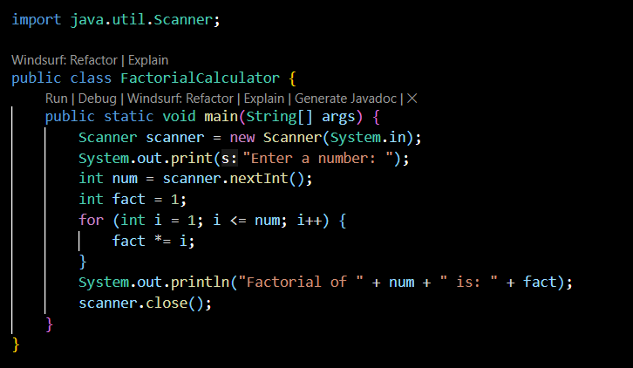
Output :
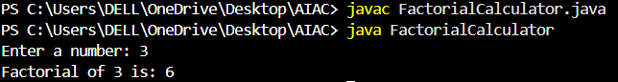
Explanation :
This program calculates the factorial of a number entered by the user.
It uses a for loop to multiply numbers from 1 up to the given number and stores the result in a variable. Finally, it prints the factorial value.
Question 3:
Few-Shot Prompting (Armstrong Number Check)
Write a few-shot prompt by providing multiple input-output examples to guide the AI in generating a java unction to check whether a
given number is an Armstrong number.
Examples:
• Input: 153 → Output: Armstrong Number
• Input: 370 → Output: Armstrong Number
• Input: 123 → Output: Not an Armstrong Number
Task:
• Analyze how multiple examples influence code structure and
accuracy.
• Test the function with boundary values and invalid inputs.
Prompt:
Code:
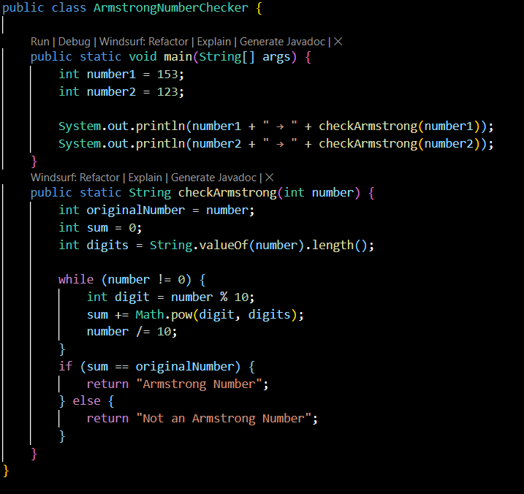
Output:
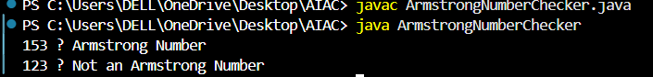
Explanation :
This program checks whether a number is an Armstrong number.
It finds the number of digits, raises each digit to the power of the total digits, and adds them. If the final sum is equal to the original number, it is an Armstrong number; otherwise, it is not.
Question 5:
Zero-Shot Prompting (Perfect Number Check)
Write a zero-shot prompt (without providing any examples) togenerate a java function that checks whether a given number is a
perfect number.
Task:
• Record the AI-generated code.
• Test the program with multiple inputs.
• Identify any missing conditions or inefficiencies in the logic.
Prompt:
Code:
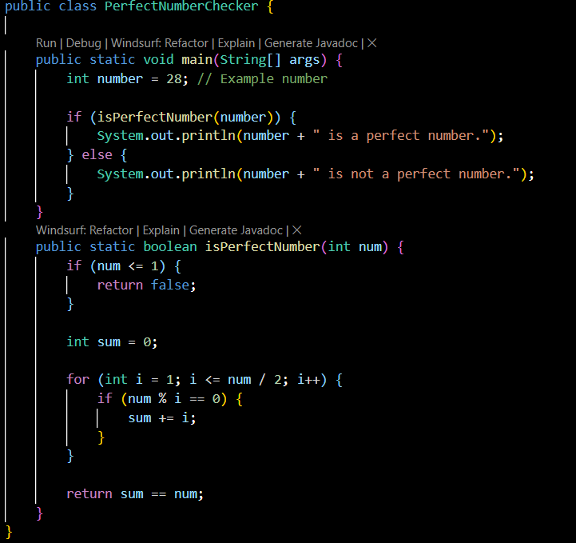
Output:
Explanation :
This program checks whether a number is a perfect number.
It finds all proper divisors of the number, adds them, and compares the sum with the original number. If both are equal, the number is a perfect number.

Question 6:
Few-Shot Prompting (Even or Odd Classification with Validation)
Write a few-shot prompt by providing multiple input-output examples to guide the AI in generating a java
program that
determines whether a given number is even or odd, including proper input validation.
Examples:
• Input: 8 → Output: Even
• Input: 15 → Output: Odd
• Input: 0 → Output: Even
Task:
• Analyze how examples improve input handling and output
clarity.
• Test the program with negative numbers and non-integer inputs.
Prompt :
Code:
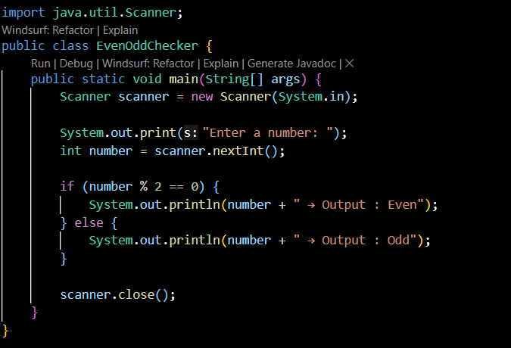
Output:
Explanation :
This program checks whether a given number is even or odd.
It uses the modulus operator (%). If the remainder when divided by 2 is zero, the number is even; otherwise, it is odd.

